GMB Bolton 23
June 2016 Issue

GMB NW&I Activists Award 2016

We are delighted to announce your branch Bolton 23 has been given an award as most active branch within the North West & Irish Region, the award was presented to us at an Activists weekend in April by our Region. Members of Branch Committee were presented with a cheque and were encouraged to set up a branch website which can be found at

www.gmbbolton23.org.uk
Pictured are Ste Dickinson - Branch Convenor & Branch Secretary, Jo Pitchford - Equalities Officer, Joint Political Officer and Joint Social Media Officer, Alan Flatley - Branch President and International Relations Officer, John Pitchford - Joint Political Officer and Joint Social Media Officer,
Paul McCarthy – GMB NW&I Regional Secretary and Simon Walsh – GMB NWI Officer for Bolton 23
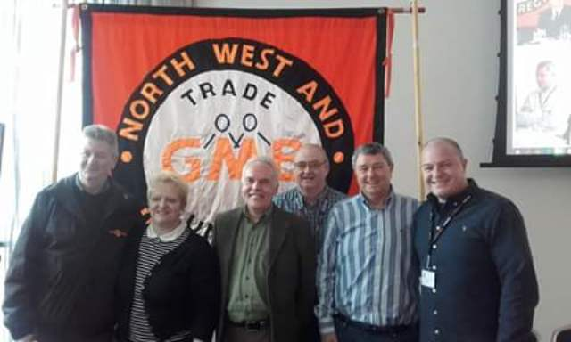
This award was presented to us as a mark of all the many things we have done as a branch over the past 12 months . These included attending political marches and rallies , attending Durham Miners Gala where we paraded the Branch banner, having a presence at the Peterloo Memorial event in Manchester, volunteering at the Wigan Diggers Festival, working on local & general election campaigns, representation on regional equalities forum and pension fund committees plus many other events across the north west. If you are interested in becoming more involvedlet us know!

GMB MEMBERS IN LOCAL GOVERNMENT & SCHOOLS TWO YEAR PAY OFFER

You may remember in the last newsletter GMB members had accepted the pay offer with UNISON and UNITE rejecting it well now we can report that they too have accepted the pay offer so watch out for a pay rise and some back pay in an upcoming pay.

It seems that whatever your GMB do one day , the other unions follow suit.

Facebook page
Bolton LG GMB 23
or the
GMB NW&I page at GBM North West & Irish Trade Union
Need to contact us
GMB Bolton 23 Branch Office 5A
Ashburner Street Market
Bolton

Telephone 01204 331122
gmb@bolton.gov.uk

Bolton
Branch 23
23

WASPI –

WOMEN AGAINST STATE PENSION INEQUALITY

If you are a women who was born on or after 6th April 1951 you will most likely be aware of the increase to the State Pension Age (SPA). Hundreds of thousands of women have had significant changes imposed on them with a lack of appropriate notification and a campaign has been set up to challenge these changes and to ask the Government to make fair transitional arrangements for all women.

Although there had been talk of a compromise solution, the new Work and Pensions Secretary has told MPs that will not be possible.“I don’t see there is a do-able policy solution,” said Stephen Crabb MP.

Members of the campaign group Women Against State Pension Inequality (Waspi) said they were disappointed, but were still hopeful that a solution could be found. Many of those affected say they have been left without enough money to live on, and not enough time to make alternative arrangements.

Under the 1995 Pensions Act, the government decided that the pension ages of both men and women would be equalised by 2020.Previously, women retired at 60, while men retired at 65. In 2011, state pension ages were raised at an even faster rate. The government has said that everyone was told about the changes, but many women say they never received the information.

Members of GMB NW&I including this branch are travelling down to London later this month to meet with our local MP’s to see what can be done to change this.

LOOK OUT FOR FURTHER UPDATES #radicalwomen #waspi

Saying goodbye to mobile roaming charges while we remain IN the EU

Mobile roaming charges within the EU were slashed even further this month. From now on, your mobile phone operator will only be able to charge you a small additional amount on top of domestic prices when you travel to another EU country. EU roaming charges will be abolished altogether in June 2017.
Ban Glyphosate!

Following on from our article regarding Glyphosate we have the following update from our colleagues in Brussels.
EU national ministers are to meet again next month to decide whether to renew glyphosate’s European license for 2 more years, pending a full safety assessment by the European Chemicals agency due next year. The EU Commission had previously proposed to renew the world’s most common weed-killer’s license for another 10 years but couldn’t find a majority of Member States to back its position. There have been severe health warnings of glyphosate’s links to cancer.

TRANSPORT CONTINGENCY FUND – TCF

WHAT CAN YOU EVEN GET FOR 10p PER WEEK THESE DAYS?
BECOME A MEMBER OF THE GMB ROAD FUND. AS A MEMBER IF YOU ARE FINED FOR A CONTRAVENTION OF ROAD TRAFFIC ACTS, YOU CAN APPLY FOR A GRANT FROM THE FUND TO OFFSET ANY HARDSHIP CAUSED.
OR MORE DETAILS RING BRANCH ON 01204 331122

Transport Contingency fund + 10p per week

WE ARE THE ONLY UNION WITHIN BOLTON COUNCIL WHO
OFFERS THIS TO OUR MEMBERS

GMB App for your iPhone or Android!
Get the latest from GMB wherever you are with the FREE GMB application. Download it to your smartphone to get instant access to GMB on the move. The apps are available now from
iTunes and Google Play for Android.

Features include:
Update your GMB profile
Get the latest news from GMB
Switch to Direct Debit
Find your nearest GMB office
Find your nearest GMB post holder
Become a workplace organizer.




